**Villa Palma Webpage**

**Competition/Website/Business/Villas examples**

<https://www.thewindmillsuffolk.com/special-offers/>

<https://instagram.com/mrandmrssmith?igshid=OGQ5ZDc2ODk2ZA==>

<https://villanai.com/>

<https://www.aman.com/>

<https://www.sixsenses.com/en>

Decent instagram - <https://www.luxurylivingcroatia.com/posts/casa-nube-awaits-you-in-gorski-kotar>

<https://www.maslinaresort.com/> - Great effects/experience while scrolling and messaging

All the pictures, reviews and extra is attached, sent separately.

**Every tab of the page should have easily position inquire now/** this should lead them to a tab where they can add their name number of guests, dates, special requests/questions and submit which should go directly to our email ([info.villapalma.molunat@gmail.com](mailto:info.villapalma.molunat@gmail.com)).

Color theme palm tree color / yellowish-brown / body of the palm tree

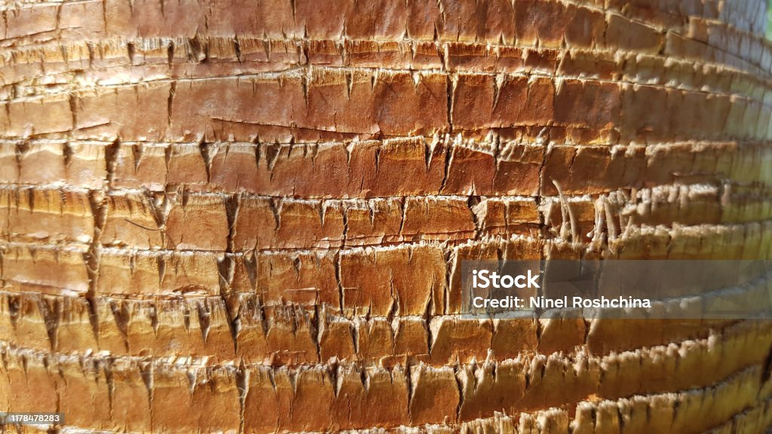

**Home landing page**

Best picture (Molunat 002) that will be the background covering each corner (ex. Villa Nai) with a message:

“Experience Mediterranean as it once was.

Authentic and untouched”

Top should have the following tabs in this order: About Villa Palma (molunat025) , History and Heritage (molunat034), Walkthrough (Gallery), Amenities and Activities (molunat010), Molunat, Cultural Compass (Blog), Contact Us (Form).

There should be a Villa Palma logo (VP with nicer font) when pressed leads back to the landing page.

Bottom should be reviews scrolling sufficiently slow for person to be able to read them. They can be in a nice window scrolling. Reviews found among attachments. Or maybe has it as separate tab since some of them are too long and leave only few short ones at the landing page? Wind Mill webpage has a nice design but moves too fast... Maybe better have reviews as a separate tab if we want to make it mobile friendly??  
  
Instagram handle should be somewhere in a corner or where it is a good fit.

**About Villa Palma**

**(a pic or two)**

Villa Palma, with its enticing charm and the gift of peace and quiet, truly captures the essence of the Croatian coast. It is, as the locals would say, “the Mediterranean as it once was”.

Perched in the western bay of Molunat, near the city of Dubrovnik, it is surrounded with both natural and cultivated vegetation on 4.5 hectares (11 acres). The most noticeable flora are the orange and olive trees planted on many terraces.

Enriched with terracotta roof and flooring, a paved stone terrace, a Tuscany ochre facade, and surrounded by orange trees, Villa Palma offers a genuine rustic ambiance that one would expect when searching for an authentic, Mediterranean experience.

If you are in need of relaxation, you will be blessed by waking up to sounds of a crystal clear sea and breathing in healing salt air. However, if you are energetic, you can follow a hidden path to your private beach, carved into the rocks, and with a natural sea pool for children.

Built in the early 20th century by local farmers, and surrounded by two hundred olive trees that have stood since the 1700s, this family home was, and remains, a source of authentic wine and olive oil, a tradition still kept alive by the family, and whose products you can taste to this day.

It is now one of the most beautiful and best-positioned villas on the Adriatic. Located in the small fishermen’s village of Molunat, it is close to the city of Dubrovnik, the town of Cavtat, the country of Montenegro, and only 20min drive from the Dubrovnik International Airport, giving you a multicultural experience within reach.

Last an uniquness to highlight is the sunsets. Villa Palma due to its oritentation and orientation of the bay has one of the most magical sunsets you will witness in your life and it is something that you cant get used to. The sun will be setting into the sea most of the summer and on a prefect day ignite everything in your sight in different shades of red.

**Molunat (a pic or two) ?**

Separate tab

Molunat is a small tourist and fishing settlement ideal for a quiet family vacation away from the city crowd. You can enjoy in peaceful beauty of the untouched nature: sandy beaches, thick oak woods and beautiful blue sea; all bathed in the enchanting aroma of Mediterranean herb s and citrus flowers.

Material remains on the peninsula, whose name is of Illyrian origin (Maluntum), bear witness to the continuity of life since ancient times. In the peace treaties from XII. century is often mentioned as the demarcation area of maritime powers (Venetian Republic and Byzantine Empire). From the end of XIV. century, the settlement of Molunat is mentioned. Since 1419, the peninsula was part of the Republic of Dubrovnik, and because of the lush vegetation, it was called Montenegro. At first it served as a shelter and quarantine for plague patients. After the construction of the defensive wall in the first half of the XV. century, which separated it from the mainland, and the arrangement of the settlement (1468), the peninsula served as a shelter in case of war danger. The accelerated development of the peninsula and settlements began for the Austrian authorities, especially after the construction of the port (1880) and the road connection with the Dubrovnik-Boka Kotorska railway. The port of Molunat then became an important station in the local passenger and commercial (oil, lime, etc.) traffic in the southeast of Konavle.

The name Molunat comes from the Greek word for the port, molos. This fact along with many archaeological findings in the area confirms the theory that Molunat has been inhabited since the ancient times. The settlement became part of the Republic of Ragusa in the 15th century. Remains of the protective wall from that period are still raising from the inland part of the Molunat peninsula.

Molunat is the perfect destination for tourists in search of an active vacation. There are numerous possibilities for recreation: diving, fishing, sailing or surfing with several paths ideal for mountain biking. Since there are no cold winds in the area, the bathing season in Molunat opens already in early May and the sea is pleasantly tempered until the late October.

Although Molunat is a small and rather isolated settlement, it offers a options for fun, adventure and memorable family holidays.

**History and Heritage**

The Metković family house was built in the 1930s, constructed by three brothers and two sisters in a traditional style using local building materials. Stone was sourced from excavations, and the binding material was lime produced in kilns still present today near the beach.

The horizontal and roof structure of the house was made from cypress wood cut on the family estate. According to local folklore, when a father had a son, he was obligated to plant at least 50 such trees so that he could later fence his house when he started his own family.

These were extremely labor-intensive tasks, as the entire summer was spent cutting down the forest to prepare enough firewood for burning the stone, which would melt into lime. At that time, there was no electricity, so everything was done manually, with horses, mules, and donkeys being the only help in transporting construction materials to the site (lime, water, wood, etc.).

The traditional construction style was a suitable way of life, with the upper floor of the house designated for living, and the ground floor serving as cellars for storing agricultural products (wine, oil, dried figs, carob, and other crops cultivated on the 48,000 m2 estate).

The income from agriculture financed the construction of the house, along with assistance from the eldest brother who had emigrated to Argentina to earn money for himself and his family. At that time, many people emigrated to North and South America in search of a better life and with the goal of helping their families survive and preserve their estates.

Hard life, strenuous work, and frequent wars forced people in this region to leave for the world, so today we have a situation where more Croats live outside Croatia than in their homeland, which is a characteristic of our family.

Upon returning from America in 1966, Mato Metković transformed the family house into a vacation home and named it "Villa Palma," a name it still carries today. The dominant position of the house overlooking the bay and the Molunat harbor was attractive to many tourists, but unfortunately, it also attracted armies that devastated it twice: after World War II from 1945 to 1950 and after the Croatia War of Independence from 1991 to 1993.

The house has been rented to tourists since 1966, with interruptions ('91 to '93 - war, 2020-2023 - complete reconstruction). Thanks to all the efforts of Metkovic family over the generations the house and the estate still continues to provide all organic produce (olives, oranges, grapes, figs, ...) to the family and their guests. Enabling a truly authentic experience at the estate. Niksa, Mato’s son, and the family continue to put love and effort to maintain this piece of paradise to the best of their ability.

Given the complete reconstruction, architects advised demolishing the old house and building a new one. However, we didn't want to demolish the four exterior walls that were the only ones left in the house, even though financially, this made the work more cumbersome and expensive.

Once, when I told a friend that I might have should have listened to the architects and demolished everything, he consoled me in an interesting way and said, "but you preserved the soul of the house."

Perhaps, unconsciously, he was right, as over 6,000 people have stayed and enjoyed their vacations in that house since it was first rented out. If someone left just a gram of laughter or kindness, it accumulated a lot because I remember from my childhood happy people, stories, laughter, and joy. My father would organize beach picnics at Pasjača, roast kid on a spit, sardine evenings, fishing trips, and long stories about the time before and after World War II, frequent escapes to the world across the Adriatic, all to earn money for the family's survival and estate.

The 70s and 80s changed the way of life, and tourism took precedence over agriculture; life became easier, and there was no need to emigrate. Our family still engages in agriculture, the local way of life, share and enjoy the products made with guests.

We produce organic extra virgin olive oil from olives planted on our estate over 250 years ago, wine made from Vranac grapes originating from Macedonia and Greece. Many oranges and lemons grow in the large orchard around the house, from which we make jam, and from carob, medlar, grapes, and walnuts, we produce homemade liqueurs.

The house has been renovated with traditional materials, most of the furniture is handmade, and modern equipment is used to achieve 5-star luxury. We invested a lot of effort, not sparing time or money, to provide original and authentically Mediterranean service with discreet luxury.

The third generation now runs this business, and the experiences and knowledge gained over the years have helped us offer and present the Mediterranean way of life in its original form to our guests. The uniqueness of the western bay of Molunat, where our estate and house are located, lies in the absence of any construction, making it probably the only undeveloped or untouched by human hands bay on the mainland part of the Adriatic.

We look forward to and will strive to provide you with an unforgettable and original experience if you decide to be our guests. Our distinctiveness lies in the experience, heritage, and knowledge gained through 60 years of renting, and glimpse of it can be found in the reviews of our old guests, whose children still come today and fondly remember the wonderful moments and time spent in Villa Palma in Molunat. What is rare in modern tourism.

Villa Palma is true beauty, a place where you "hear the silence" and enjoy the beauty of untouched nature with all your senses. In the truest sense, it is "the Mediterranean as it once was."

In honor to the old guests that have spent their hard earned vacation we left their review here as well.

Pictures to support the story 2-3? Old pictures, produce

**Walkthrough**

Add gallery of the pictures to be scrolled or seen in an easy and smooth fashion alongside or under the walkthrough description (All house picture and the best few of produce, animals...):

As you enter the Villa’s spacious living room, a dining table for eight welcomes you. This room is detailed with a terracotta floor, a large leather sofa, a big-screen LED TV, and a provencal-style kitchen — all this and an impressive view of the sea through a large sliding glass door and window.

The kitchen is large and fully equipped, with oakwood and terracotta accents. This makes it easy to prepare a light lunch as well as an elaborate dinner, as are the traditions in the Mediterranean.

The Villa has four bedrooms, each with wood-framed high ceilings and modern queen-size double beds, built-in custom-made closets, and en suite bathrooms with showers. The rooms are airy and relaxing.

Two spacious terraces, three balconies and a pool-surrounding terrace are scattered on multiple levels allowing you to choose between savoring the Adriatic sun or just day-dreaming in the cool shade of trees around the property.

The swimming pool is a 5 x 14 meter-long infinity pool which makes you feel like the pool and the sea are continuous. It is equipped with baldachins (canopies), and sun beds are an option if you decide not to go to the beach. In the evenings this can become your favourite sunset viewing spot. Add a glass of your favourite beverage, and it becomes a pleasant and relaxing moment.

Fronting the main house is a covered BBQ area where you have the possibility of grilling fresh fish caught by local fishermen in the bay in front of the Villa. If you are a fish lover, note that the main fishing season is May and June, when you can observe tuna and yellow-tail being caught regularly.

And for anything else you desire, the proprietor can be your concierge. Perhaps you would like a master chef to prepare a special dinner for you at the Villa. Or for local homemade food to be brought to you. Or a boat rental for the day, SCUBA diving lessons, wine tasting at a local winery, a special fish dinner at a cozy Cavtat restaurant, various excursions to Dubrovnik or to the Montenegro coastal area, or simply your favorite Champagne at sunset by the pool. We will be at your side when you need us, so that every moment can be as perfect as Villa Palma itself.

**Amenities and Activities**

Amenities

Experience authentic Mediterranean in our fully equipped four-bedroom villa. Enjoy private beach access with a natural pool, sun loungers, and boat mooring. Our concierge offers personalized services, from wellness to private chefs. Immerse yourself in an authentic Mediterranean experience on our fully fenced estate with domestic animals on it. Benefit from the freshest seasonal organic produce from the farm. The infinity pool provides panoramic sea and mountain views and stunning sunsets as can be seen from the pictures. Outdoor amenities include 2 spacious terraces with Mediterranean vegetation, barbecue, shower, sun loungers, and baldachins.

Activities

Within the myriad of options available, we've singled out a selection for you to delve into further, tailoring your choices based on your preferences—whether you lean towards active pursuits, spiritual exploration, relaxation, or a culinary journey. The family is readily available to recommend you activities and provide insider tips to fit your desires and energy levels, ensuring a personalized and enriching experience. Just to highlight a few here alongside the links for you to explore further:

* Beautiful national parks and islands
* Rafting in one of the deepest river canyons in Europe
* Explore Dubrovnik, unique UNSECO protected medieval city
* Walk on the second longest stone wall in the world after Great Chinese Wall
* Local culinary specialties
* Dubrovnik Summer Festival
* And more…
  + <https://platanus.hr/private-excursions/>
  + <https://visitdubrovnik.hr/activities/hiking/#routes-around-konavle>
  + <https://croatia2go.com/a-day-tour-of-konavle-valley-in-the-renault-4/>
  + <https://www.dumus.hr/en>
  + <https://www.redhistorymuseum.com/>

Experiences..

You can experience Croatian culture and a glimpse into the old lifestyle. You will leave with vivid pictures of historic buildings, and a better understanding of Croatian history, its culture and its people. This is often missing in modern tourism.

Many of the local people still live in sync with the nature around them. Depending on which season you arrive, there will be different traditions and customs to observe. Each season brings different activities for the local farmers and fishermen. With the guidance of your host, you can share these experiences with the local people while you are here.

You can experience the diversity of Croatian gastronomy. There are numerous family-owned restaurants in the area. Some are surrounded by beautiful vegetation with a river running quietly by, where you can dine on a shaded terrace.

If you are looking for something unique in this world of abundance, then we are sure your stay here will be an enriching experience for you and your family and friends.

We will be happy to help you organize whatever you crave at the time. Just ask!

**Cultural Compass**

Welcome to our blog where we share stories and blogs about the culture, history of the region and other bits dear to our heart.

Blog section to add blogs on life/food and other posts related to the villa and the region/culture. What would be the blog format?

**Reviews?**

Post old and new reviews?

**Contact us**

Contact form that will be when they press on each page. At the bottom email ([info.villapalma.molunat@gmail.com](mailto:info.villapalma.molunat@gmail.com)) and phone number +385 98 428 555